***GOLD COAST DISTRICT GOLF ASSOCIATION***

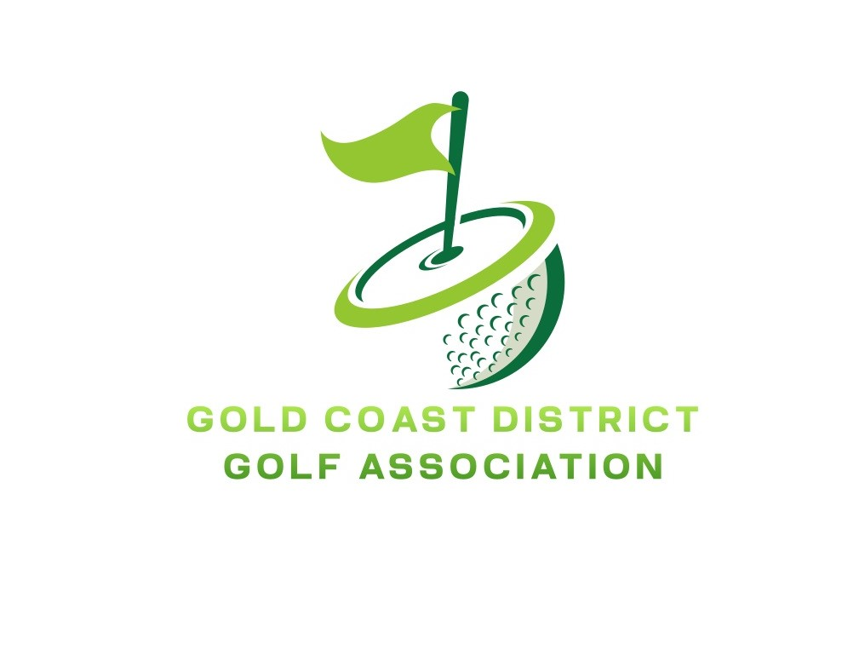

***RESULT SHEET Round 1 9TH FEBUARY***

Played at: SOUTHPORT GC

|  |  |  |  |  |  |
| --- | --- | --- | --- | --- | --- |
|  | ***Club: TAMBORINE MT***  ***Manager: GERRY MOLONEY*** | ***Win/***  ***Loss*** | ***Club: SURFERS PARADISE***  ***Manager: GERRY CAFFERKEY*** | ***Win/***  ***Loss*** | ***Margin*** |
| **7** | MITCH CARNEY | SQ | EAMON LENNON | SQ | SQ |
| **6** | KERRY WHEAR | L | SAM CORIMA | W | 5/4 |
| **5** | TODD BLOCKSIDGE | L | TRENT ROSE | W | 7/5 |
| **4** | LIAM MOLONEY | L | PAYTON HAYWARD | W | 6/4 |
| **3** | EDDIE MILLS | L | JACOB MONTGOMERY | W | 4/3 |
| **2** | DEREK SHIRLAW | L | LIAM CAFFERKEY | W | 5/3 |
| **1** | PETER ARNESEN | L | ENJAH ROHAS-SMITH | W | 5/4 |

**SURFERS PARADISE 6 ½ Matches Defeated TAMBORINE MT ½ Matches**