***GOLD COAST DISTRICT GOLF ASSOCIATION***

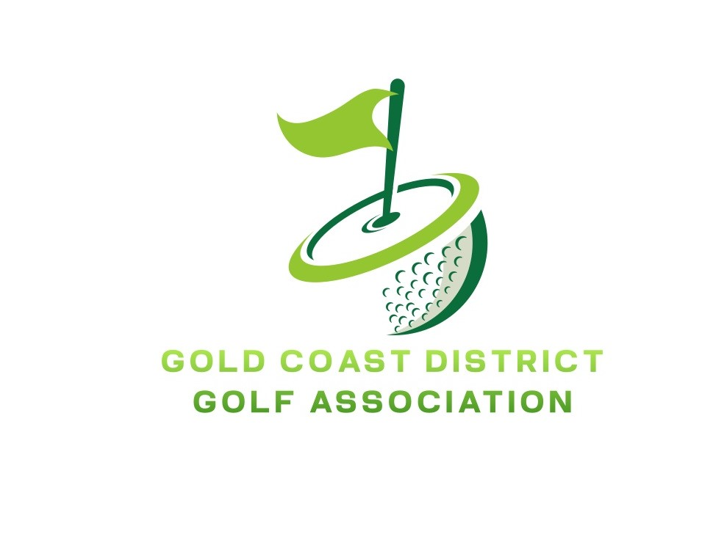

***RESULT SHEET Round 1***

Played at: SANCTUARY COVE GC

|  |  |  |  |  |  |
| --- | --- | --- | --- | --- | --- |
|  | ***Club: BURLEIGH***  ***Manager: ROBERT TEECE*** | ***Win/***  ***Loss*** | ***Club: LINKS HOPE ISLAND***  ***Manager: MATT WILLIAMS*** | ***Win/***  ***Loss*** | ***Margin*** |
| **7** | BRADON ADAMSON | W | RAYNE SOBERLUND | L | 7/5 |
| **6** | ASHLEY BEAKE | W | SAM TAYLOR | L | 6/4 |
| **5** | BEN DALY | SQ | JAMES CARTER | SQ | SQ |
| **4** | DYLAN STONER | W | ANTHONY SLAGG | L | 4/2 |
| **3** | MARK HILL | L | PAUL MCGEE | W | 2/1 |
| **2** | JAKE FRAME | W | ADAM BAKER | L | 4/3 |
| **1** | RAY BEAUFILS | L | ALEX WHITELY | W | 2/1 |

**BURLEIGH 4 ½ Matches Defeated LINKS HOPE ISLAND 2 ½ Matches**