GOLD COAST DISTRICT GOLF ASSOCIATION
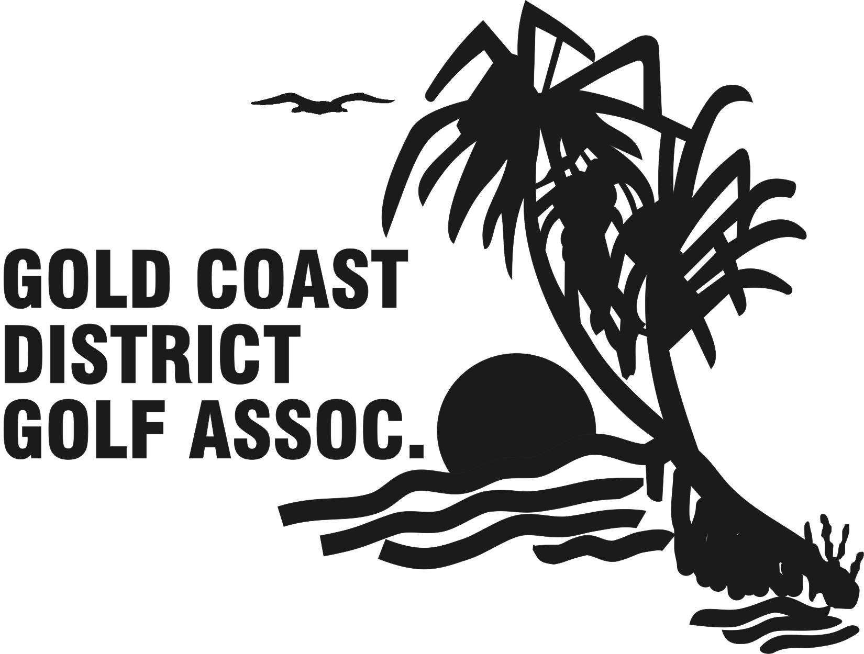
RESULT SHEET
ROUND 4: 3rd March 24
Played at: Royal Pines GC

 | Club: Links Hope Island  Manager:  Matt Wiiliams | Win/  Loss | Club:Emerald Lakes  Manager:  Marty Bourzain | Win/  Loss | Margin
7 | Mark Quinn | SQ | David Hammett | SQ | SQ
6 | Mario Coutts | L | Ben Ratcliff | W | 4/2
5 | Paul McGee | L | Joshua Liston | W | 9/8
4 | Anthony Slagg | SQ | Owen Acherberg | SQ | SQ
3 | Sam Taylor | L | Kyle Gray | W | 7/6
2 | Alex Whitely | W | Mark Burrell | L | 3/2
1 | Alex Yap | L | Kai Komulainen | W | 2/1

OVERALL MATCH RESULT

EMERALD LAKES GC 5 Matches Defeated LINKS HOPE ISLAND 2 GC Matches
GOLD COAST DISTRICT GOLF ASSOCIATION
RESULT SHEET
ROUND 4 : 3 rd March 24
Played at: Sanctuary Cove GC

 | Club: Burleigh GC  Manager:  Robert Teece | Win/  Loss | Club: Mt Tamborine  Manager:  Gerry Moloney | Win/  Loss | Margin
7 | Callum Agius | W | Scott Briggs | L | 9/7
6 | Allan Weise | W | Kerry Whear | L | 6/5
5 | Chris Johns | W | Mitch Carney | L | 5/4
4 | Ryan Rodgers | W | Trevor Ridge | L | 5/3
3 | Jack Fox | W | Liam Moloney | L | 7/5
2 | Mark Hill | L | Peter Arnesen | W | 4/3
1 | Ray Beaufils | W | Mitch Revie | L | 1up

OVERALL MATCH RESULT

BURLEIGH GC 6 Matches DEFEATED MT TAMBORINE 1 GC Matches
GOLD COAST DISTRICT GOLF ASSOCIATION
RESULT SHEET
ROUND 4: 3RD March 24
Played at: Royal Pines GC

 | Club: Surfers Paradise Gc  Manager:  Gerry Cafferkey | Win/  Loss | Club: Lakelands GC  Manager: | Win/  Loss | Margin
7 | Payton Hayward | L | Adam Young | W | 1up
6 | Cooper Sulbotic | SQ | Jim Mc Culloch | SQ | SQ
5 | Jacob Montgomery | SQ | David Mc Gill | SQ | SQ
4 | Trent Rose | W | Jack Lea | L | 4/3
3 | Laim Cafferkey | W | Clark Hopley | L | 5/3
2 | Elijah Rohas-Smith | SQ | Nick Schneider | SQ | SQ
1 | Billy Dowling | W | Ryosei Mizuno | L | 5/4

OVERALL MATCH RESULT

Surfers Paradise GC 4 ½ Matches DEFEATED Lakelands GC 2 ½ Matches

GOLD COAST DISTRICT GOLF ASSOCIATION
RESULT SHEET
ROUND 4: 3rd March 24
Played at: Southport GC

 | Club: Coolangatta Tweed  Manager:  Nino Santone | Win/  Loss | Club: Sanctuary Cove  Manager:  Nick Mullins | Win/  Loss | Margin
7 | Sam Daley | W | Dylan Stoner | L | 5/4
6 | Jackson Love | W | Paul Smerden | L | 3/2
5 | Jacob Tonkin | W | Sasha Cooper | L | 3/1
4 | Matthew Begg | L | Daniel Cai | W | 3/1
3 | Glen Baker | L | Ethan Leighon | W | 1up
2 | Ben Adams | W | Taylor Barr | L | 2/1
1 | Sam Adams | L | Alfie Ward | W | 3/2

OVERALL MATCH RESULT

Coolangatta Tweed Gc 4 Matches DEFEATED Sanctuary Cove 3 Matches

GOLD COAST DISTRICT GOLF ASSOCIATION
RESULT SHEET
ROUND 4: 3rd March 24
Played at: Sanctuary Cove GC

 | Club: Royal Pines GC  Manager:  Grant Wallace | Win/  Loss | Club: Southport GC  Manager:  Darren Chiswick | Win/  Loss | Margin
7 | Hans Yim | L | Chris Melia | W | 6/4
6 | Adam Hawkins | W | Kyle Brasher | L | 4/2
5 | Yutaro Matsushita | L | Lee Manning | W | 1up
4 | Harrison Gomaz | W | Zach Jansen | L | 5/4
3 | Chay Taccori | W | Mark Chiswick | L | 3/1
2 | Isaac Rahmani | SQ | Nick Pfieffer | SQ | SQ
1 | James Goffman | W | Peter Lyon | L | 1up

OVERALL MATCH RESULT

Royal Pines GC 4 ½ Matches DEFEATED Southport GC 2 ½ Matches

TEAM STANDINGS
AFTER ROUND FOUR
3rd MARCH 2024

BLUE SERIES
TEAM | PLAYED | W’OUT | BYE | SQ | WIN | LOSS | FOR | AG’T | PTS
EMERALD LAKES | 4 |  |  |  | 4 |  | 20 | 8 | 8
SANCTUARY  COVE | 4 |  |  |  | 2 | 2 | 18 ½ | 9 ½ | 4
SURFERS  PARADISE | 4 |  |  |  | 2 | 2 | 12 ½ | 15 ½ | 4
LAKELANDS | 4 |  |  |  | 1 | 3 | 12 | 16 | 2
LINKS HOPE  ISLAND | 4 |  |  |  |  | 4 | 6 | 23 | 0

RED SERIES
TEAM | PLAYED | W’OUT | BYE | SQ | WIN | LOSS | FOR | AG’T | PTS
ROYAL PINES | 4 |  |  |  | 4 |  | 20 ½ | 7 ½ | 8
BURLEIGH  GC | 4 |  |  | 1 | 2 | 1 | 17 | 11 | 5
SOUTHPORT  GC | 4 |  |  | 1 | 2 | 1 | 16 | 12 | 5
COOLANGATTA  TWEED | 4 |  |  |  | 2 | 2 | 14 | 14 | 4
TAMBORINE  MT | 4 |  |  |  |  | 4 | 3 ½ | 24 ½ | 0

